

MARKET ANALYSIS FOR BOOKS



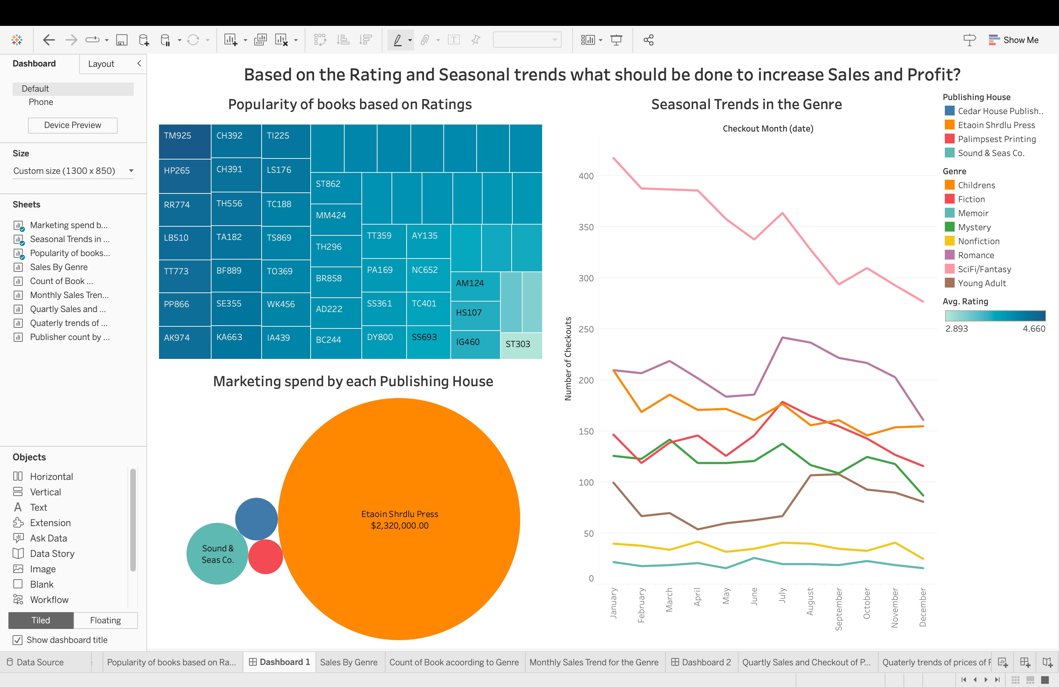

Dashboard 1 – Based on the Rating and Seasonal trends what should be done to increase Sales and Profit?

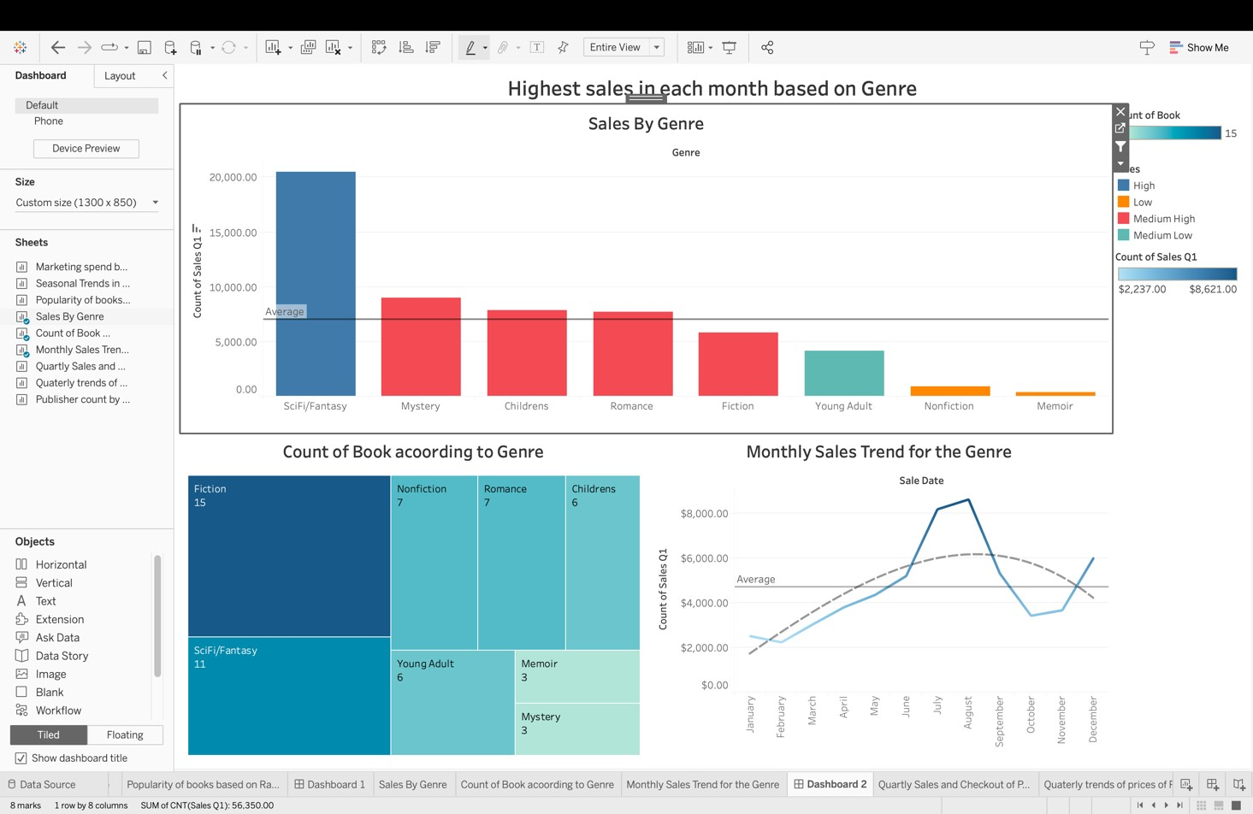

Dashboard 2 – Highest sales in each month based on Genre

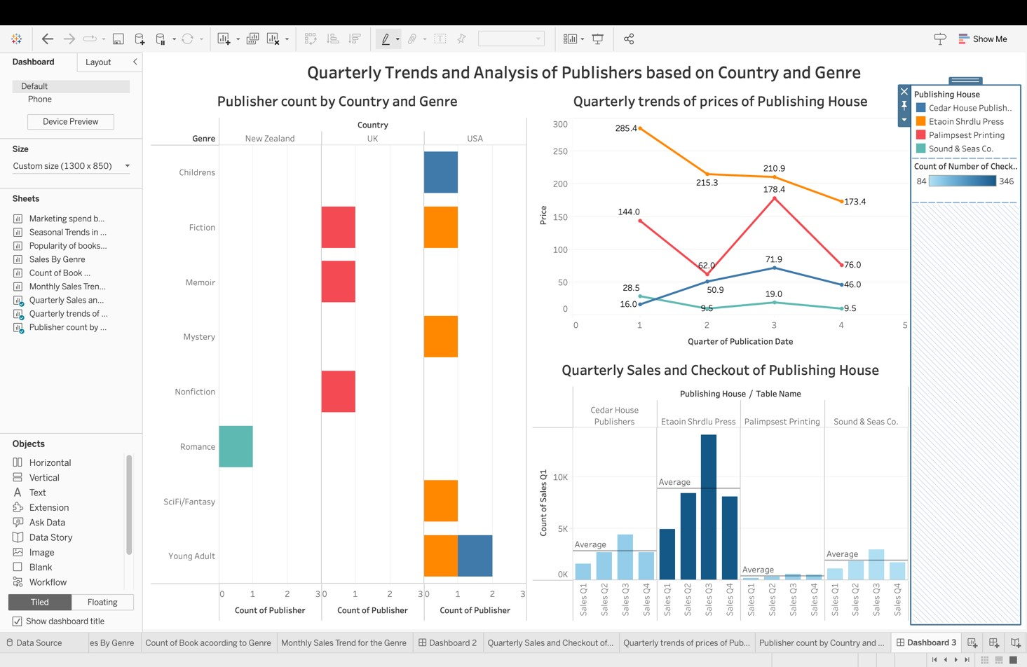

Dashboard 3 – Quarterly Trends and Analysis of Publishers based on Country and Genre

1. The work is significant because it offers valuable information and data-driven insights related to the popularity of books based on ratings, marketing spends by publishing houses, seasonal trends in genres, sales by genre, count of books according to genre, monthly sales trends for genres, quarterly sales and checkout of publishing houses, trends of prices by publishing houses, and publisher count by country and genre. This comprehensive view enables stakeholders to make.

1. Based on the presentation, stakeholders can make a range of decisions, including:
   * Identifying popular books based on ratings to focus on marketing and promotional efforts for those titles.
   * Assessing the effectiveness of marketing spend by each publishing house and reallocating resources accordingly.
   * Analyzing seasonal trends in genres to align publishing schedules and marketing campaigns with peak demand periods.
   * Understanding sales performance by genre and using that information to guide investment and marketing decisions.
   * Managing inventory levels based on the count of books according to genre to optimize supply chain operations.
   * Adjusting pricing strategies based on quarterly trends to maximize profitability.
   * Analyzing publisher count by country and genre to identify market opportunities and tailor marketing strategies.

1. Some key insights that can be gained from the work include:
   * Understanding the relationship between book ratings, seasonal trends, and sales to identify potential strategies for increasing sales and profit.
   * Evaluating the return on investment (ROI) for marketing spend by each publishing house to optimize resource allocation.
   * Recognizing the genres that demonstrate consistent popularity and leveraging that information to guide publishing decisions.
   * Identifying quarterly sales and checkout trends to understand the performance of publishing houses and potential growth opportunities.
   * Analyzing price trends and their impact on sales to optimize pricing strategies and maximize revenue.
   * Assessing the distribution of publishers by country and genre to identify regional strengths and potential partnerships.

1. Without specific details about the graphs/charts included in the worksheets and dashboards, it is challenging to provide specific decision points. However, stakeholders can make decisions such as:
   * By analyzing the popularity of books based on ratings, stakeholders can identify potential bestsellers and allocate resources accordingly.
   * Marketing teams can make decisions about adjusting budgets or reallocating funds based on the effectiveness of marketing spend by each publishing house.
   * Seasonal trends in genres can inform decisions regarding publishing schedules, marketing campaigns, and inventory management.
   * Sales by genre can guide decisions about resource allocation, genre-specific marketing strategies, and partnership opportunities.
   * The count of books according to genre can help publishers understand market saturation or gaps, inform production decisions, and guide inventory management.
   * Monthly sales trends for genres can aid in planning promotional activities, optimizing publishing schedules, and aligning inventory levels with demand.
   * Quarterly sales and checkout trends of publishing houses can identify growth opportunities, evaluate publisher performance, and inform business strategies.
   * Price trends by publishing house can guide decisions regarding pricing strategies, discounts, and promotions.
   * Publisher count by country and genre can reveal market potential, guide international expansion efforts, and facilitate targeted marketing campaigns.

1. By connecting these logically connected charts/graphs, stakeholders can make decisions such as focusing on popular genres, optimizing marketing efforts, aligning publishing schedules with seasonal demand, adjusting pricing strategies, and identifying growth opportunities in specific countries or genres. This holistic approach enables stakeholders to make data-driven decisions that can lead to increased sales and profitability.

Stakeholder Identified: Customers

**Dashboard 1:**

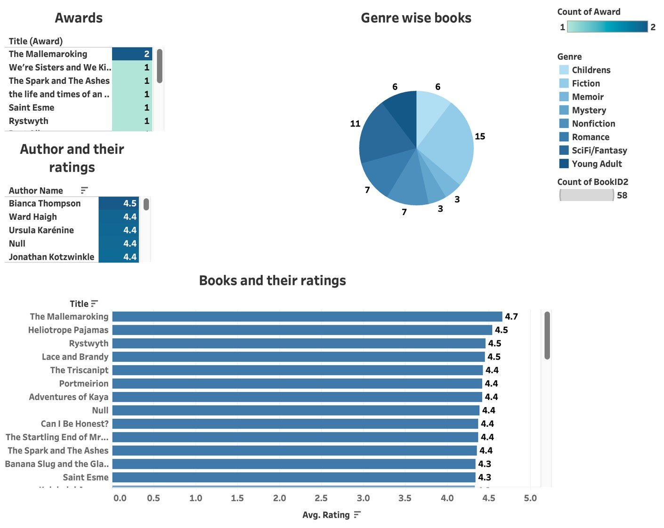

This dashboard gives an overall overview of all the books in the store. This dashboard is ideal for a customer to determine which book they are interested in in terms of the author, the no. of awards it has received, what genre it belongs to as well individual ratings.

* + For customers who like to buy their books based on the genre, the chart “Genre wise books” will give them an overview of how many books belong to a particular genre. The interactive feature of tableau lets them select a particular genre after which they will be able to see just the books of a particular genre. They will also be able to check out the customer ratings of all these books for easier decision making. They can now check the authors for each book of interest with the average rating for the author. Additionally, they will be able to understand the number of awards a book received.
  + For customers who are fond of an author can choose the author of their choice along with the author’s average rating using the chart “Author and their ratings”. Because of the interactive feature, they can check out which genres the books of a particular author belong to. They will get a list of books using the chart “Books and their ratings” and understand every book’s rating. Additionally, they will be able to understand the number of awards an author’s book or books received.
  + For customers who want to read critically acclaimed books, the “Awards” chart gives a list of all the books that won awards. Once you select a particular book with one or more awards, you will be able to see the author with the author’s average rating, the genre a particular book belongs to as well as the rating of the book in concern.
  + Finally, for customers who just want to explore new books, the chart “Books and their ratings” will give information on all the books which are arranged from highest to lowest ratings.

**Dashboard 2:**

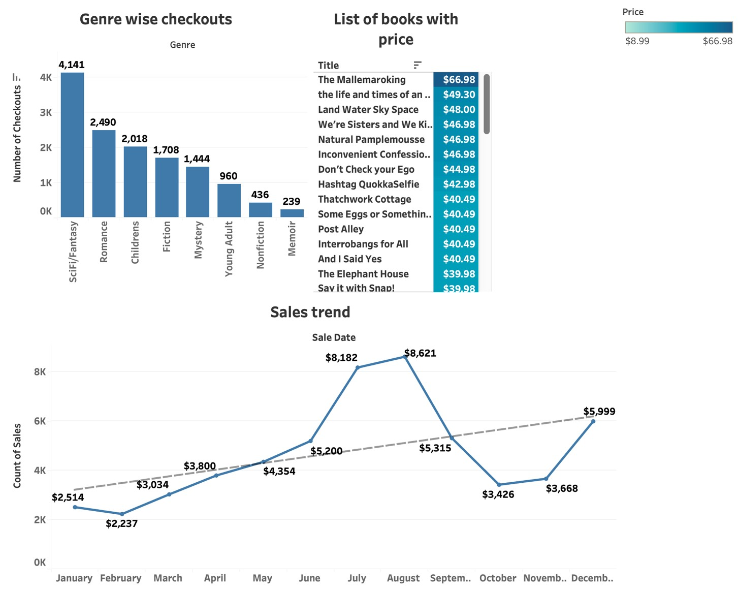

This dashboard gives an overall idea of the sales, checkouts for each book and genres along with the price of every book.

* + After a customer has decided to buy a particular book or a book belonging to a particular genre, the chart “Genre wise checkouts” will tell the customer how popular the genre has been in the past. If the customer selects a particular genre, a list of all the books under that genre will pop up with the prices. They will also be able to see the sales trend for that genre through the chart “Sales trend”.
  + This dashboard also allows the customer to get a list of all the books with its price and help the customer choose a book within his/her price range. After the book selection, the customer will be able to analyze the sales trend for that book.

**Dashboard 3:**

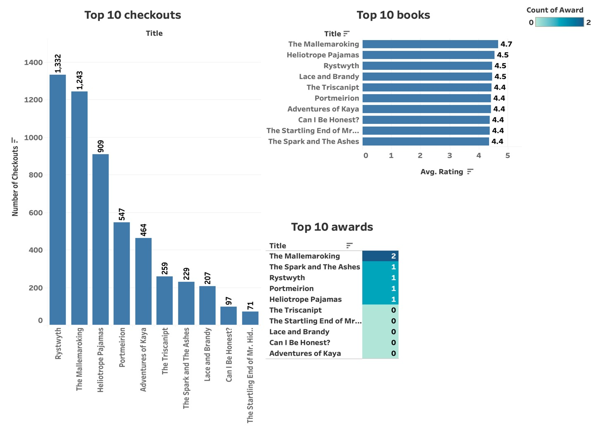

This dashboard would act to verify if the decision made by a customer, is the correct decision. The entire dashboard gives information of the same 10 books filtered based on top rated books.

* + The first chart “Top 10 checkouts” gives us the information on the books sold the most historically. It gives the customer the no. of checkouts of the books in the past. Once the customer has decided on buying the book, he can check if the book belongs to this dashboard, as the entire dashboard is filtered on the top 10 books according to the ratings. The customer now knows if the top-rated book is also sold in a good volume, making it a popular book too.
  + The chart “Top 10 awards” tells the customer if the top-rated book is also critically acclaimed and has won some awards.
  + The third chart “Top 10 books” gives information on the top 10 books with the highest customer rating.
  + Overall, this dashboard is a good way for the customer to double check if the decision made by the customer to buy the book falls in line with all the 3 important aspects of the book i.e. the no. of copies sold, the customer rating and the awards won by that book. If the customer is unhappy with the choice, he/she can always visit the first 2 dashboards to choose a new book that falls in line with the expectations.

Stakeholder Identified: Publishers

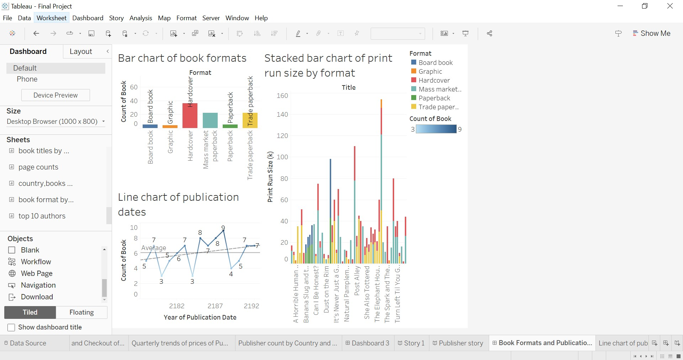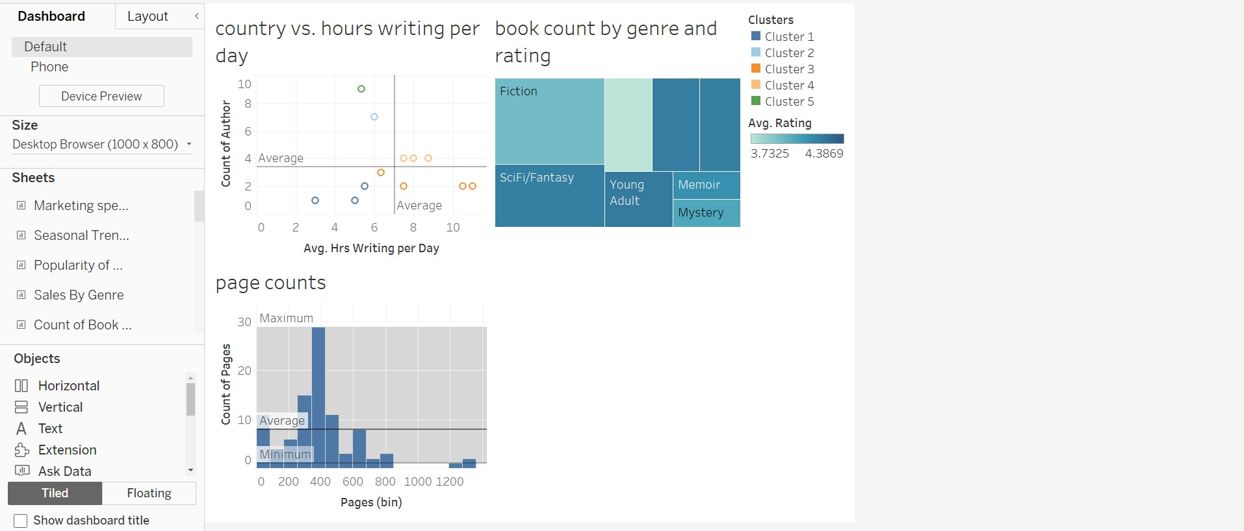

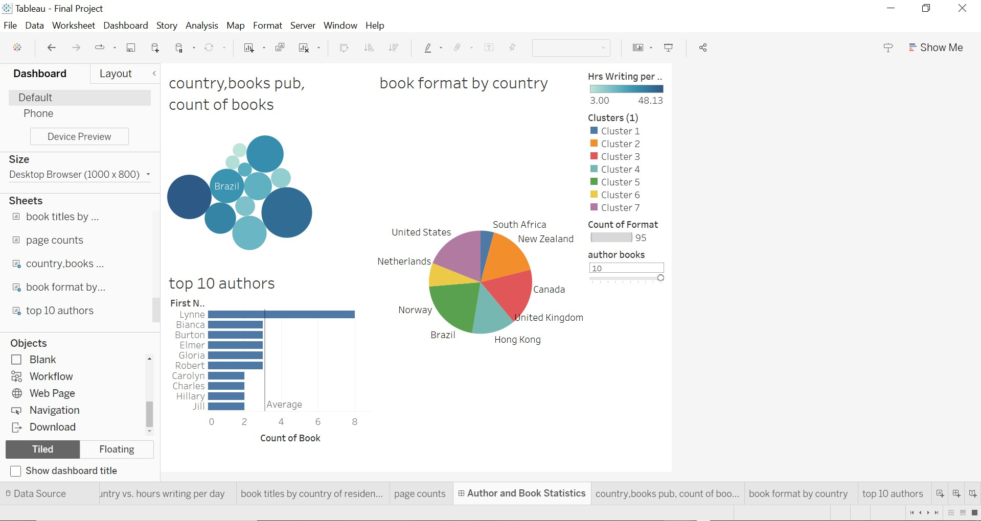

1) The given dataset of book information can be analyzed to provide insights and valuable information for various stakeholders such as publishers, authors, and readers. For publishers, three dashboards have been suggested which cover book formats, publication dates, author statistics, and book statistics. The first dashboard includes a bar chart of book formats, a line chart of publication dates, and a stacked bar chart of print run size by format. The second dashboard comprises a scatter plot of author country vs. hours writing per day, a heat map of book titles by country of residence, and a histogram of page counts. The third dashboard includes a bubble chart of author country, hours writing per day, and number of books published, a pie chart of book formats by author gender, and a bar chart of the top 10 authors by the number of books published. Overall, these dashboards provide stakeholders with meaningful insights that can be used to make informed decisions about book publishing and marketing strategies.

2)

Based on the presented dashboards, publishers can make several informed decisions. For example, Dashboard 1 provides insights into book formats and publication dates, allowing publishers to make strategic decisions regarding the types of books to publish and when to release them. Dashboard 2 offers author statistics, enabling publishers to identify promising authors and build relationships with them based on their country of residence and writing habits. Dashboard 3 combines author and book statistics to offer a comprehensive overview of authors and their work. This allows publishers to identify trends and patterns in authorship and book formats, ultimately leading to better decision-making and increased success in the publishing industry.

1. Analysis of book data can provide publishers with valuable insights into their business operations. The presented dashboards help publishers visualize book formats, publication dates, and print run sizes, which can help in planning future publications and identifying trends. Additionally, author statistics such as country of residence, hours writing per day, and book titles published can help in identifying potential authors to work with and understanding their writing habits. The analysis of book formats by author gender and the top 10 authors by a number of books published can also provide publishers with information on successful authors and which book formats are popular among certain genders. These insights can ultimately help publishers make informed decisions on future publications, author acquisitions, and marketing strategies.

1. Dashboard 1: Book Formats and Publication Dates
   * Bar chart of book formats: Publishers can make decisions about the types of formats to prioritize based on the popularity of each format.
   * Line chart of publication dates: Publishers can identify trends in publication dates and plan future releases accordingly.
   * Stacked bar chart of print run size by format: Publishers can make decisions about print runs based on the popularity of each format.

Dashboard 2: Author Statistics

* + Scatter plot of author country vs. hours writing per day: Publishers can identify countries with high productivity and potentially scout for new talent in those regions.
  + Heat map of book titles by country of residence: Publishers can identify regions where their authors have the most success and potentially target marketing efforts in those areas.
  + Heat map depicting the average rating, count of books by genre.

Dashboard 3: Author and Book Statistics

* + Bubble chart of author country, hours writing per day, and number of books published: Publishers can identify high-performing authors and potentially offer them more lucrative contracts or incentivize them to write more.
  + Pie chart of book formats by author gender: Publishers can identify trends in book formats favored by male or female authors and potentially adjust their marketing efforts accordingly.
  + Bar chart of the top 10 authors by number of books published: Publishers can identify their topperforming authors and potentially offer them more resources or prioritize their work in marketing efforts.

1. Looking at the logically connected charts and graphs, stakeholders can make informed decisions about various aspects of their business. For example, by examining the book format and publication date graphs, publishers can determine which formats are most popular and which publication dates result in higher sales. By analyzing the author statistics, publishers can identify the most productive authors and the countries with the highest output. They can also gain insight into author preferences, such as the relationship between country of residence and writing productivity. The author and book statistics dashboard provides information on author productivity and book formats by gender, as well as identifying the top 10 authors based on the number of books published. Overall, stakeholders can use these insights to make data-driven decisions about their business strategies, such as determining which authors to work with, which formats to prioritize, and which countries to target for book sales.

**StakeHolder Identified: Production Manager**

# Dashboard 1

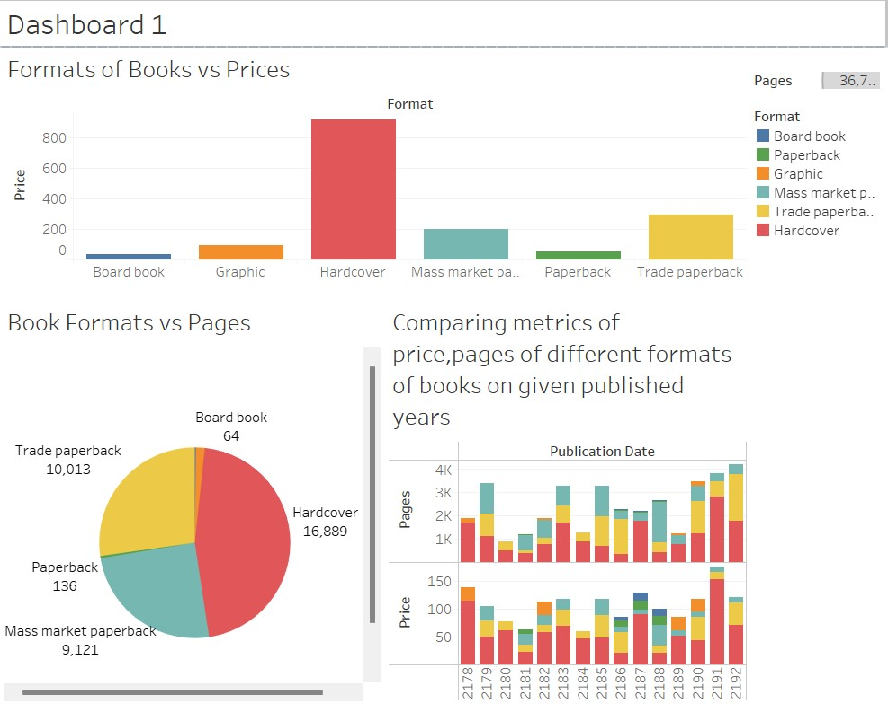

# Dashboard 2

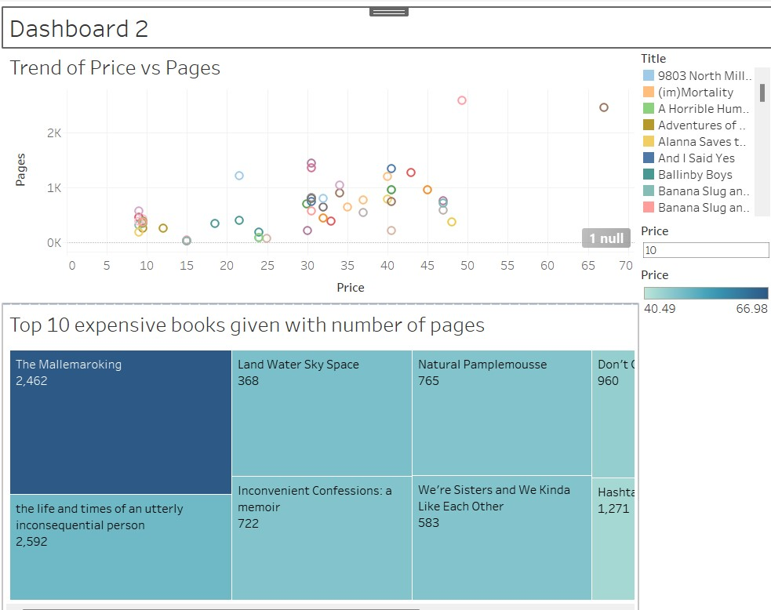

# Dashboard 3

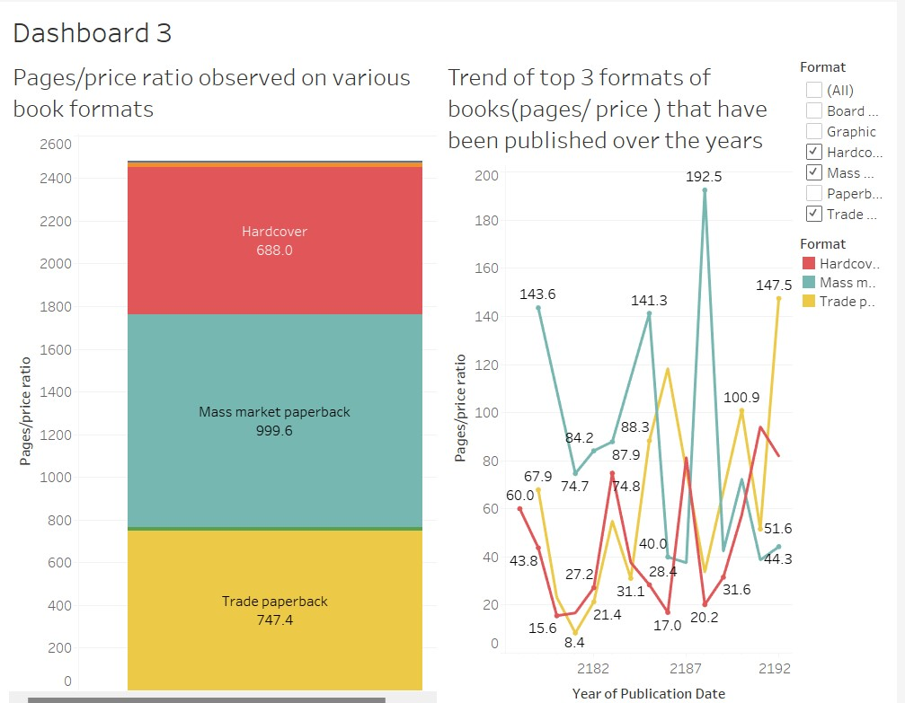

**1)** **What is your work's significance?**

I have taken production manager as a potential stake holder,a production manager oversees the physical creation of a book. They would determine or advise on the best formats for a book based on its content, length, and the intended audience. They would also have a role in determining the costs associated with different formats.This dashboard provides an overview of the relationships between book formats, prices, and pages. The dashboards can help address complex questions and business problems. By revealing trends, correlations, and outliers, they can assist in identifying potential opportunities or issues. By revealing trends over time, these dashboards can help inform long-term strategies and forecast potential future market scenarios **2) What are some key insights one can gain from your work?**

From the bar graph in Dashboard 1, we can see which book formats tend to be more expensive. This insight can guide production decisions, such as whether to focus on certain formats to maximize profits.

The pie chart in Dashboard 1 shows how the number of pages varies among different book formats. This can give a sense of market preferences for longer or shorter books in specific formats, informing decisions about the content length for future books.

The side-by-side horizontal bar chart in Dashboard 1 reveals how total book length and prices have evolved over the years. This can suggest market trends that a production manager could take into account when planning future publications.

The scatter plot in Dashboard 2 illustrates the relationship between book price and the number of pages. If longer books tend to be more expensive, a production manager might consider this when determining book length and pricing.

The tree map in Dashboard 2 shows the most expensive books and their page counts. If high-priced books tend to have certain characteristics, like a larger number of pages, this could inform the approach to producing and pricing future high-end books.

The line graph in Dashboard 3 reveals how the pages-to-price ratio has changed over time for different book formats. Understanding these trends can help the production manager anticipate which formats might be more profitable in the future.

**3) What are some key insights one can gain from your work?**

Book Formats have a higher price point and are well-received in the market, a decision could be made to focus more on producing those formats to increase revenue.

If the number of pages tends to vary across formats, and there's a trend showing consumer preference for longer or shorter content in certain formats, decisions could be made to adjust the content length accordingly.

If longer books generally command higher prices, it may indicate a willingness from consumers to pay more for comprehensive content. This could lead to decisions to adjust pricing strategies for future books, based on their length and complexity.

Insights from the top 10 most expensive books can guide decisions on creating future high-end books. If high-priced books tend to have certain characteristics, like a larger number of pages, emulating these characteristics in future high-end books could be a strategic move.

If the pages-to-price ratio varies over time for different book formats, it could guide long-term strategies, such as investing more in the formats with a higher ratio as they may provide a better return on investment in the future.

**4) For each graph/ chart – what decision can the stakeholder make by looking at it?**

The data visualized in this **dashboard 1**can answer complex questions such as:

What is the relationship between book format and price? Are there any certain formats consistently more expensive?

How does the number of pages vary across different book formats? Does this suggest a preference for longer or shorter content in certain formats?

The data visualized in this **dashboard 2** can answer complex questions such as

Is there a definitive correlation between the price of a book and its length?

Do high-priced books also tend to have more pages?

The data visualized in this **dashboard 3** can answer complex questions such as Which format is cost effective?

Which are the formats that are produced high pages/price ratio

**5) how does it connect to a larger decision that is possible by looking at a few logically connected charts/graphs?**

The Production Manager can use this information to understand the general market dynamics.Book seller can also be used to make use of this data and make concrete decisions. Above dashboards we've discussed provide several different views into the data, each focusing on different relationships and trends. Individually, each dashboard offers valuable insights. Still, when connected logically and viewed as a whole, they can inform broader strategic decisions in the book production and publishing process and improving cost-effective techniques that can improve the process of making books and also can help in taking the right decision.

# Stakeholder Identified: Market Analyst

**Dashboard 1:**

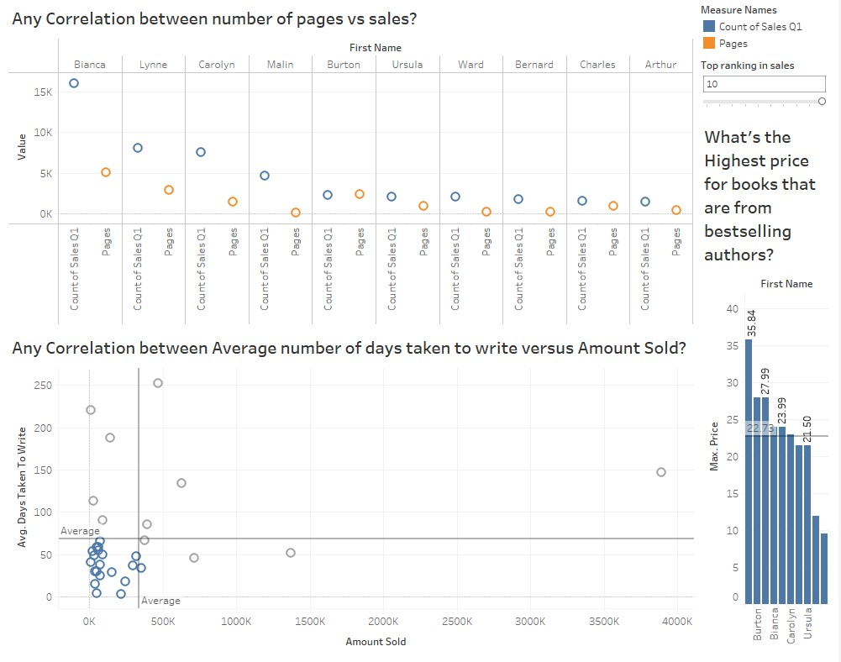

**Dashboard 2:**

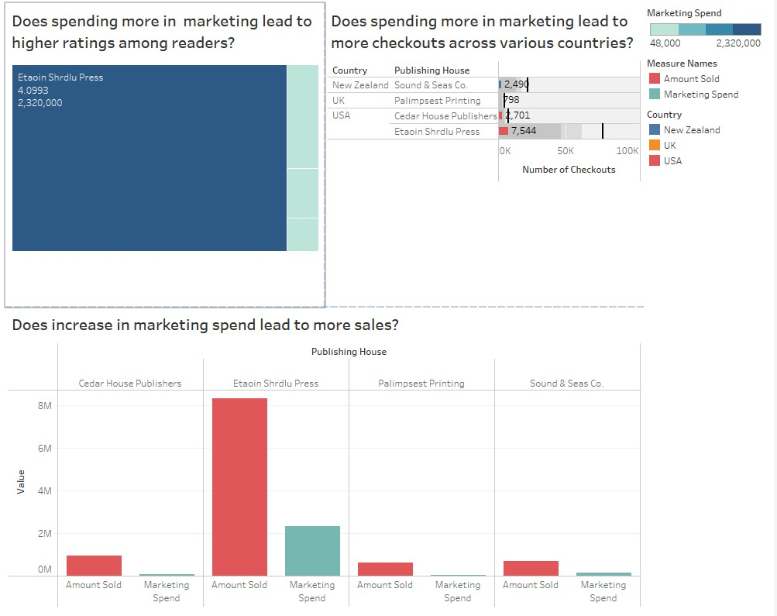

**Dashboard 3:**

